**HTTP -> Hyper text Transfer Protocol.**

*History and version* : -

1. Http -> 1991
2. Http 1.0 -> 1996
3. Http 1.1 -> 1997 (Most used version)
4. Http 2 -> 2015
5. Http 3 -> 2018

* Client side and Server side to communicate with each other they need to HTTP .

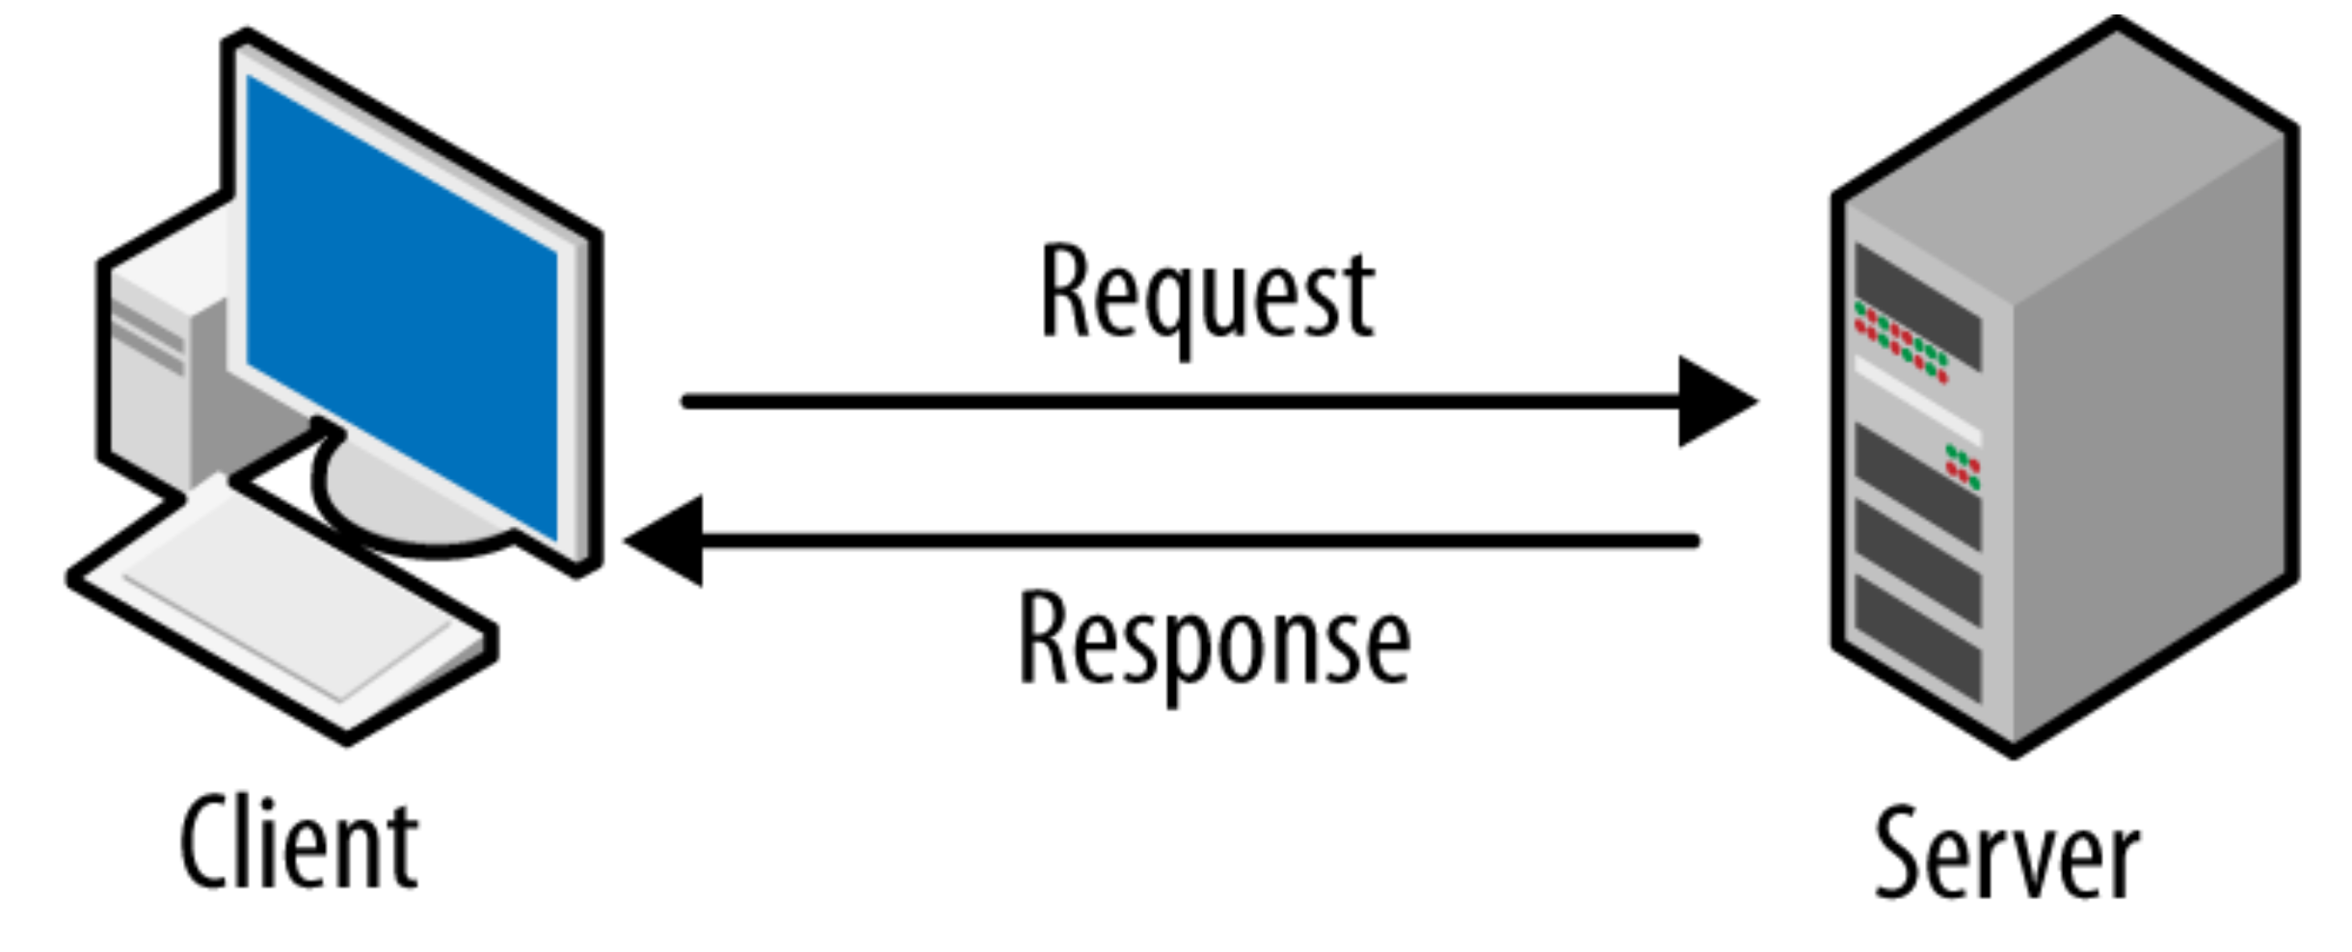

* Client Talking with the server ---> Request .
* Server Talking with the client ---> Response .
* (A) HTTP Request includes : -

1. URL .
2. Method Type .
3. Headers .
4. Body .

1-) URL : -

* The title of the page you want to go .

- includes :-

* protocol : (HTTP , HTTPS) .
* Host : (Domain name) .
* Port : (Indicating the technical "gate" used to access the resources on the web server) .
* Path : (indicating the location of the resource on the web server) .
* Application context : (Is the query string, which are extra parameters provided to the web server) .

2-) Method Type : -

* Type of request sent .

-Ex :-

* GET – HEAD : (Used to request data) .

- The HEAD is faster and more efficient , but does not return any content .

* POST : (Used to send data to a server) .
* PATCH – PUT : (Used to update data) .
* DELETE : (Used to delete data) ,

3-) Headers : -

* Contain more information about the client requesting the resource .
* consists of -> Key : Value .

4-) Body : -

* Contain more data to send through the Request .

- Ex :-

(Text , Image , Video , File , Binary file) .

* (B) HTTP Response includes : -

1. Status Code .
2. Headers .
3. Body .

1-) Status Code :-

When a browser sends a request to a server, the server responds with a three-digit .

- Ex :-

* 200 : The request was successful .
* 301 : Moved permanently .
* 302 : Moved temporarily .
* 400 : Client error .
* 403 : The client does not have access to the content .
* 404 : Not found .
* 500 : Internal server error .
* 502 : Bad gateway , got an invalid response .
* 503 : Service unavailable , server is down for maintenance or that is overloaded .

2-) Headers :-

* ( Key : value ) sent by a server in its response to a client’s request .

3-) Body :-

* The response body contains the data that the client asked .